***Details of Students’ Seminar***

***on***

***“Exploring Career Options in Financial Markets”***

**Organized By**: Department of Commerce, Vidyanagar College in Collaboration with Bombay Stock Exchange Institute – Kolkata in Association with IQAC Vidyanagar College

**Date and Time**: 4th October, 2024 (Friday) 12 Noon on words.

**Venue:** Seminar Hall, Vidyanagar College

**Total Number of Participants Attended**: 132 participants.

**Resource Persons:**

* Ms. Amrita Dutta, Dupty Manager, Bombay Stock Exchange Institute Limited.
* Mr. Tamal Choudhari, Assistant Manager, Bombay Stock Exchange Institute Limited.
* Mr. Tirtha Pratim Saha, NISM Exam Coordinator & Marketing Executive, Bombay Stock Exchange Institute Limited.

**Convener:**

* Mr. Subrata Das, Assistant Professor of Commerce (Convener)
* Mrs. Doyel Aich, Assistant Professor of Commerce (Joint Convener & Nodal Officer of Internship Programme)

**Learning Outcomes:**

* Students get clear understanding about the stock market, it’s operations and Mutual funds.
* Students able get information what are the courses offered by Bombay Stock Exchange Institute.
* Students also get the knowledge about the future benefits if they attend the courses offered by Bombay Stock Exchange Institute.

**Sample Certificate**

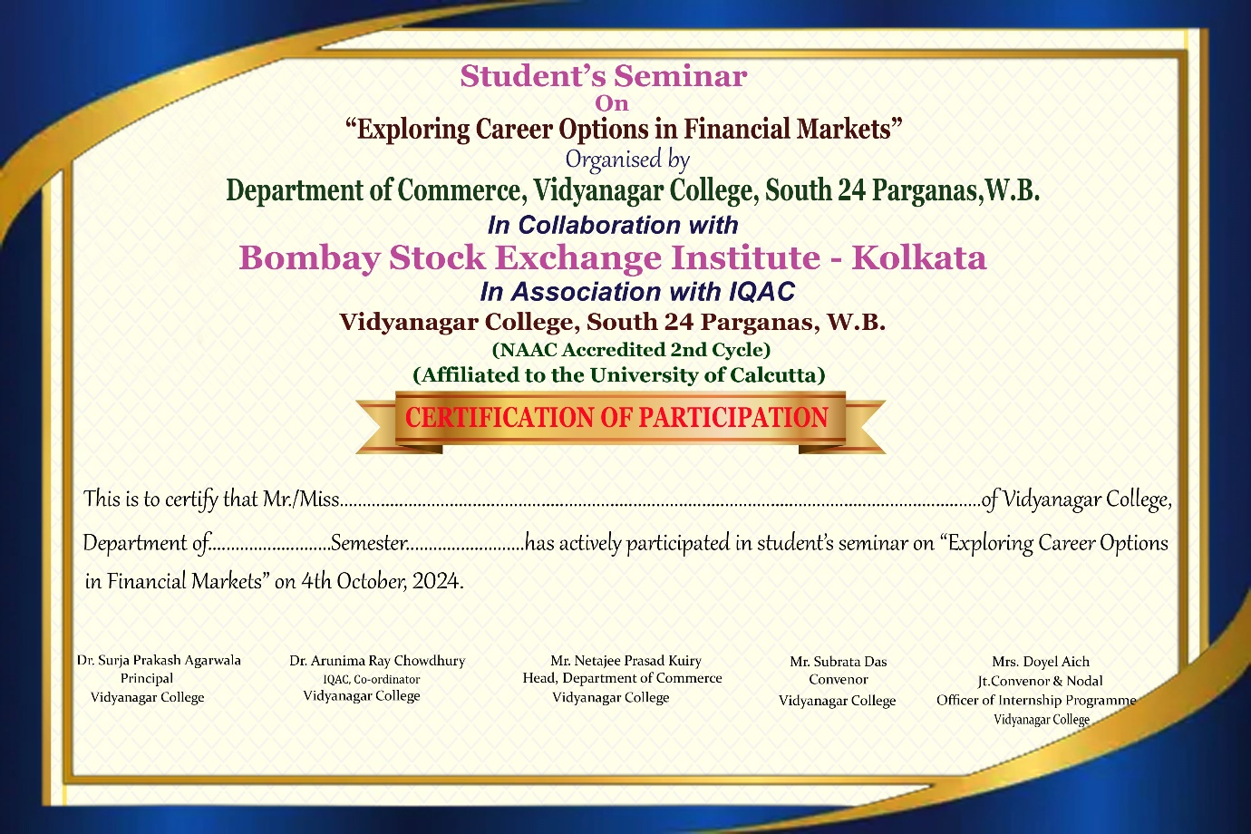

**Sample Pictures of the Seminar**

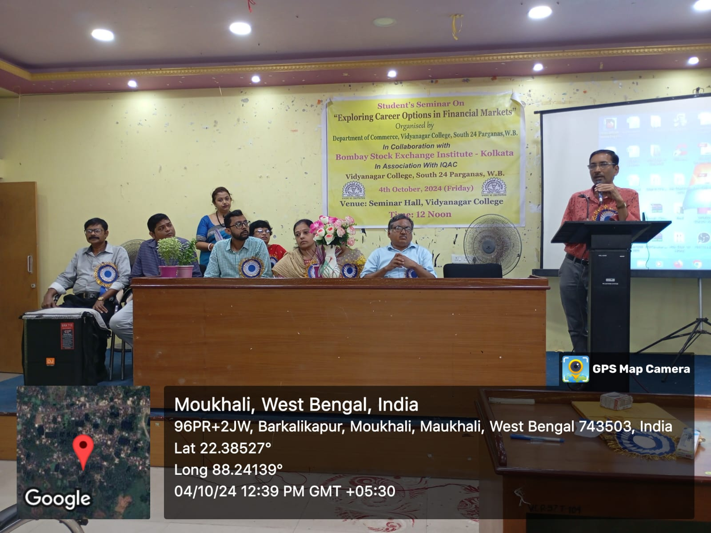

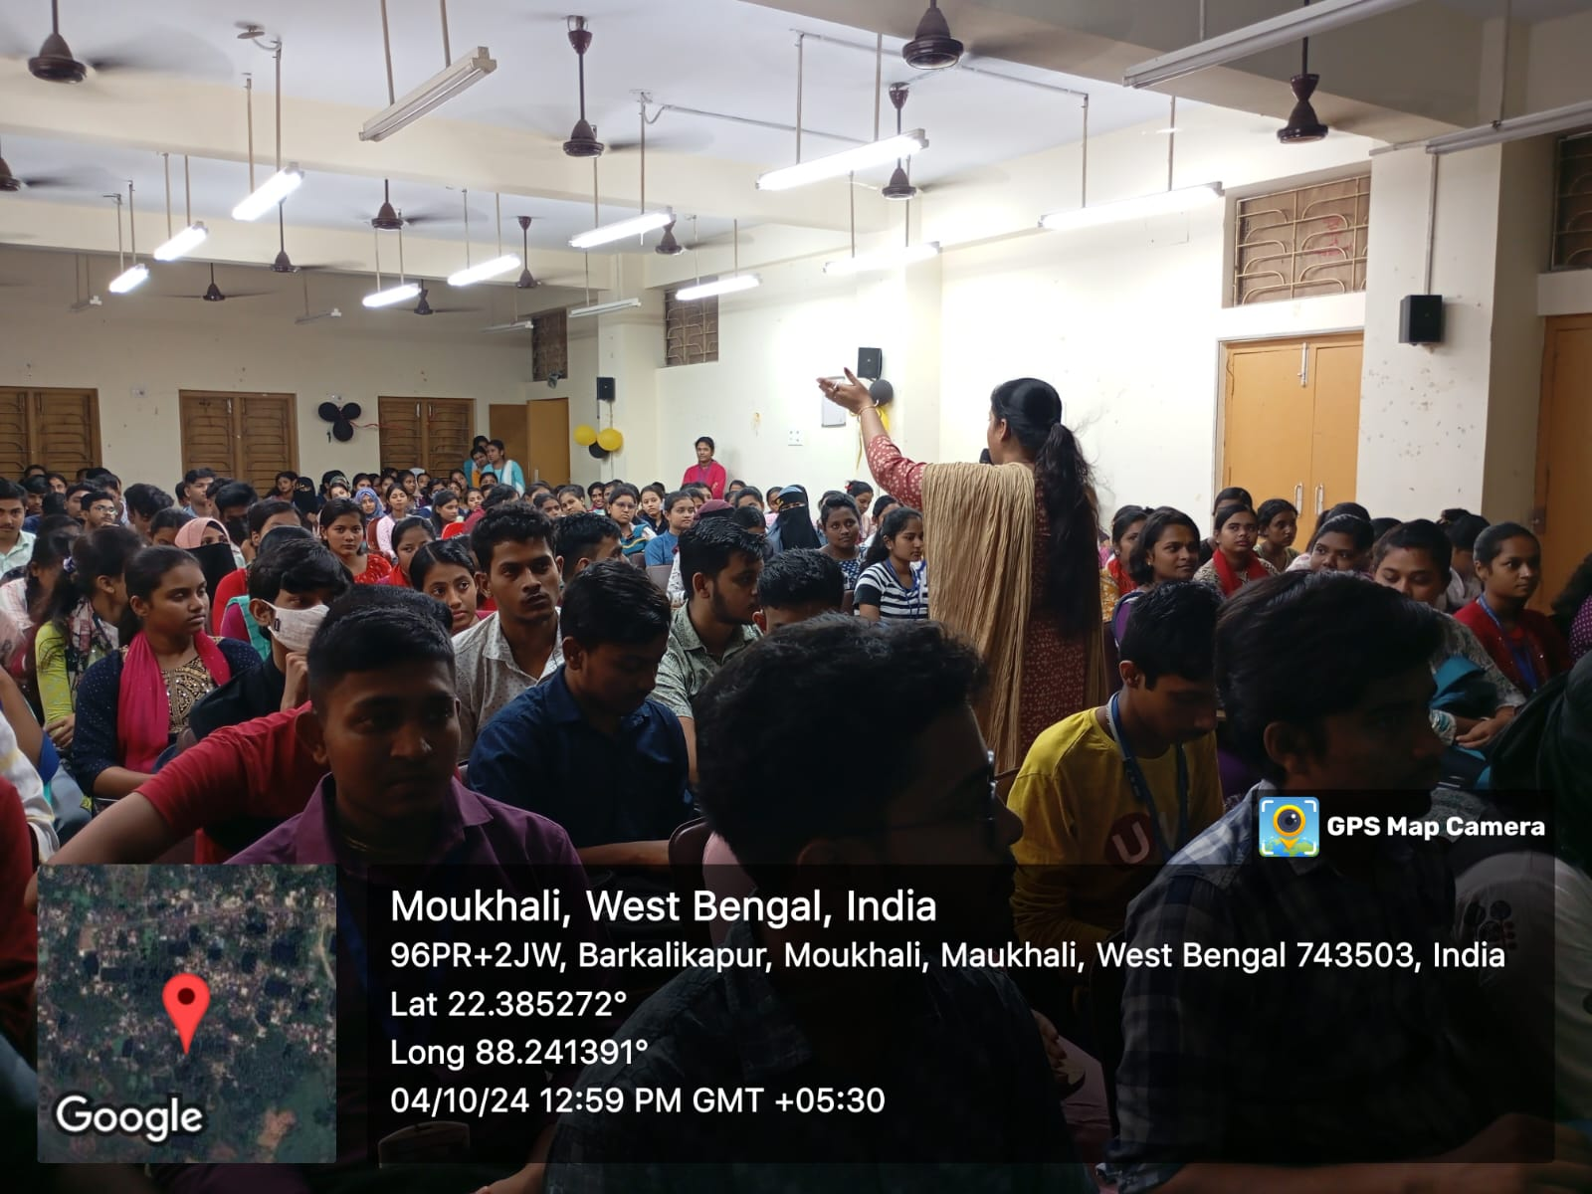

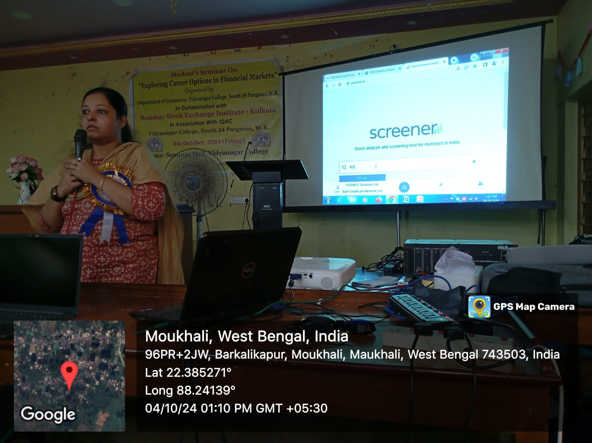

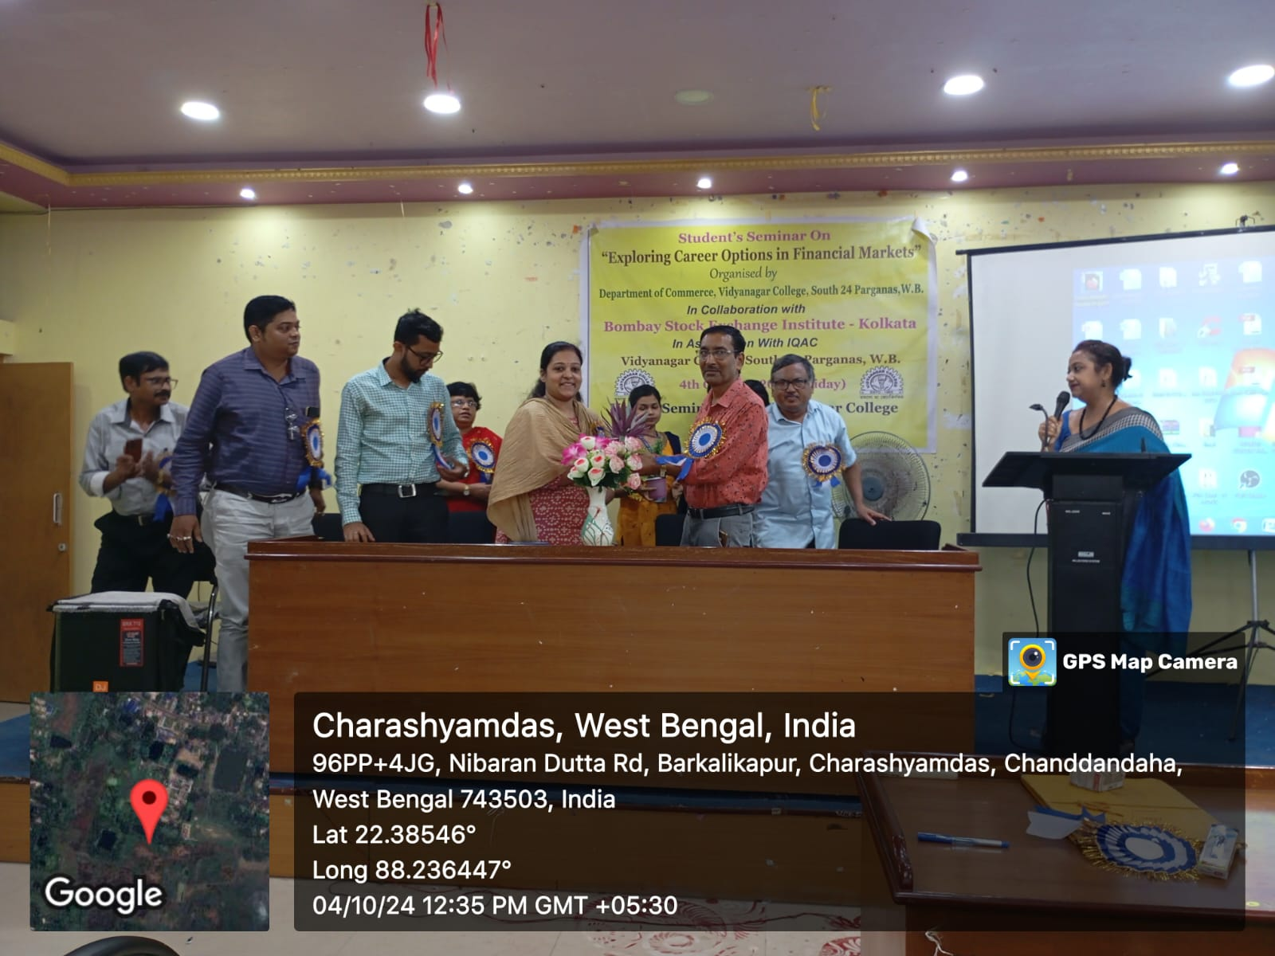

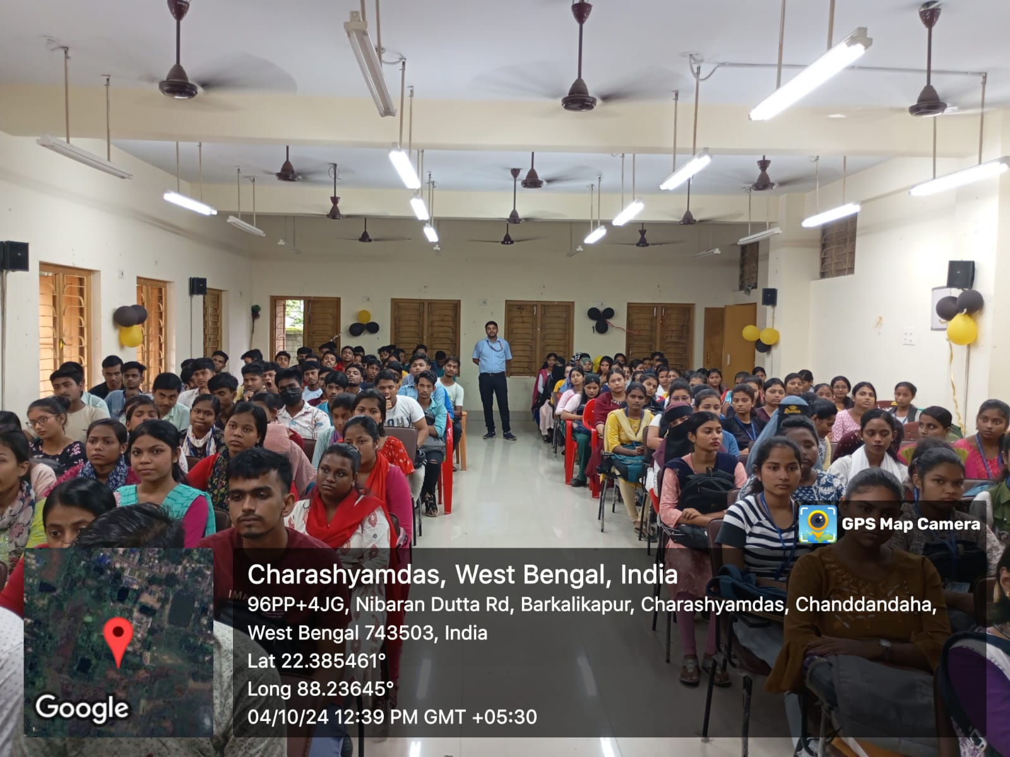

**Signature of Principal**

**Signature of Convenor Signature of Joint Convener**

**Signature of IQAC Coordinator with Remarks**