**Details of Excursion**

***on***

***“EXCURSION TO A PREMIER EDUCATION CUM CAREER FAIR, 2024”***

**Organized By**: The ICSI in association with Shri Shikshayatan College, Kolkata

Programme name: “Udaan-Dreams Personified: Career Pathways Expo”

**Date and Time**: 21st September, 2024 (Saturday) 11 am onwords.

**Venue:** Shri Shikshayatan College

**Total Number of Participants Attended**: 81 participants.

**Excursion Guide:**

* Subrata Das, Assistant Professor of Commerce, Vidyanagar College.
* Doyel Aich, Assistant professor of Commerce, Vidyanagar College.\
* Monalisa Bhowmick, State Aided College Teacher, Vidyanagar College.

**About the Programme:**

It was a career expo, where over 50 renowned colleges and universities and more than 3000 students from diverse academic backgrounds will come together. The event offered a unique platform to connect students with educational institutions and industries, guiding them on their journey towards a successful career.

**Learning Outcomes:**

* Students are able to know regarding the changes made in job market.
* Students are benefitted to know about the now avenues of higher studies.
* They all got a scope to interact and share their thoughts with the students from other colleges.
* They also get opportunity to clear their doubts about alternative career options while interacting with the experts from different field of studies.

***Sample Pictures of the Excursion***

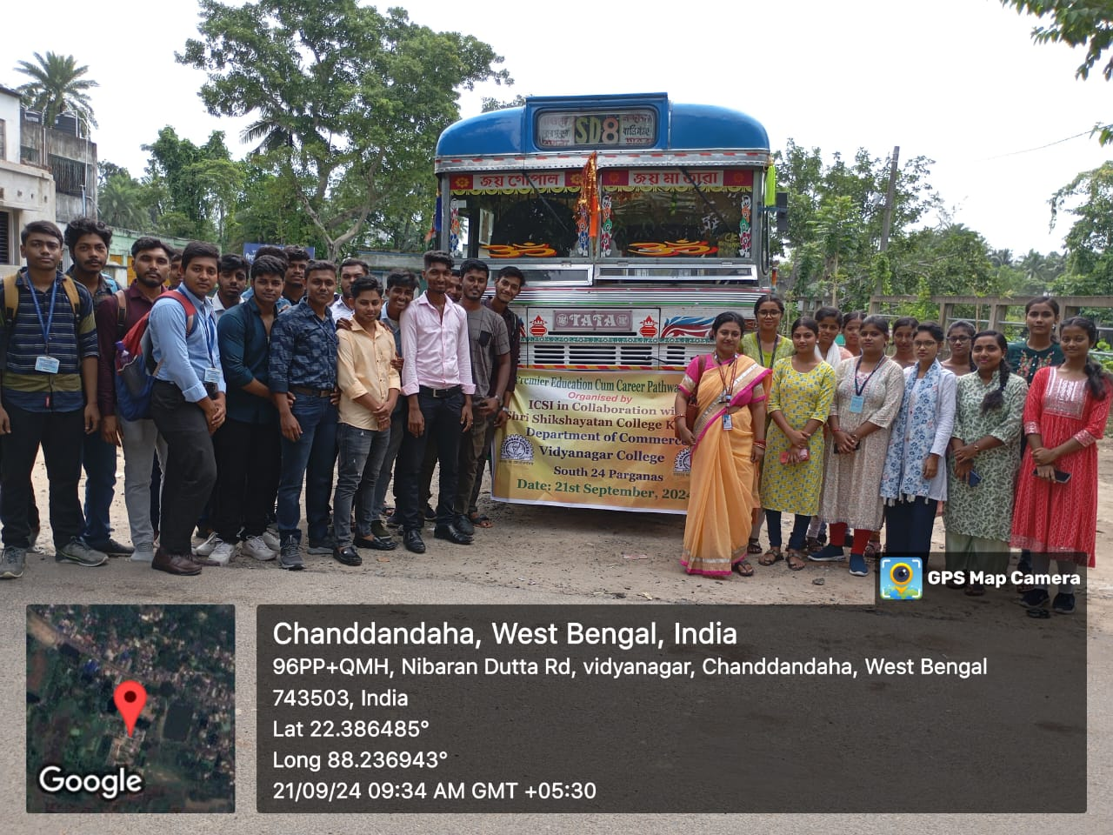

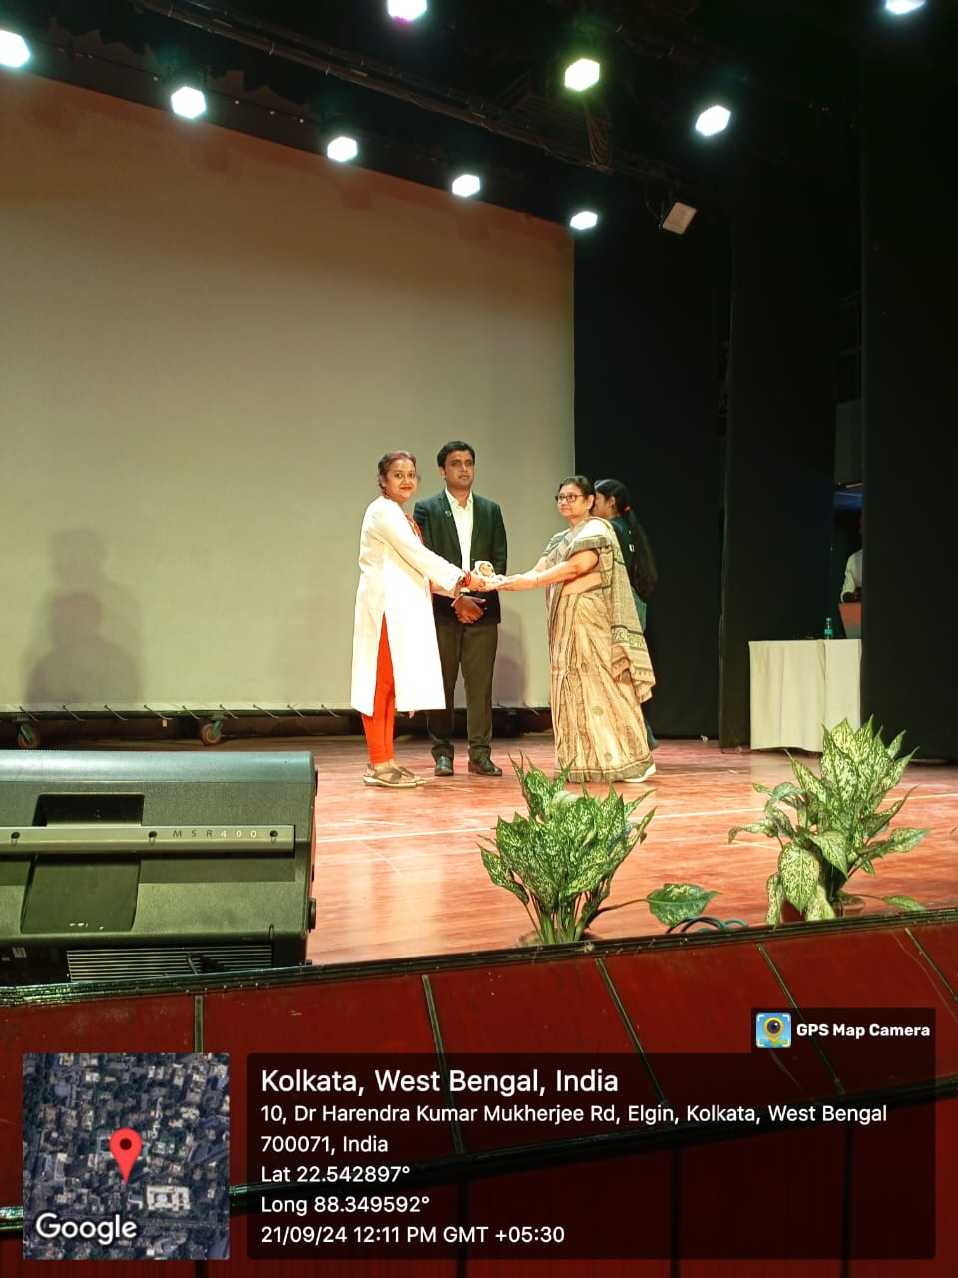

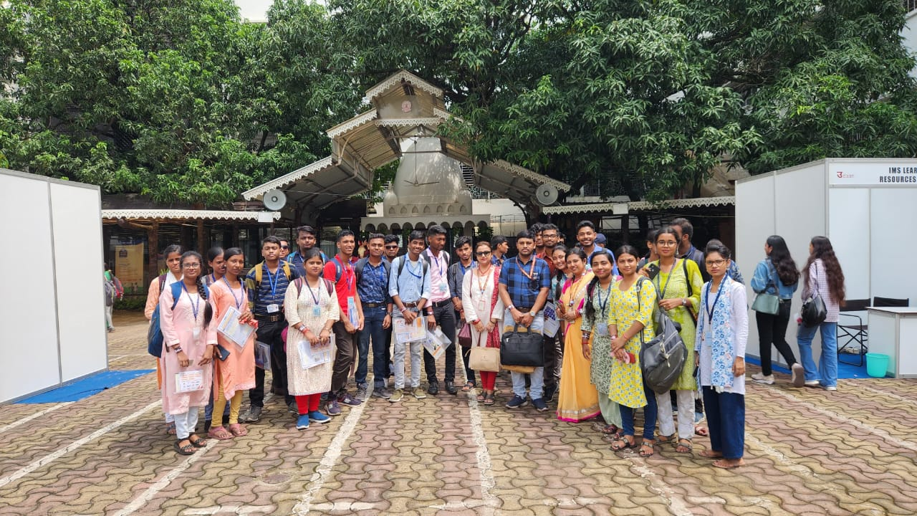

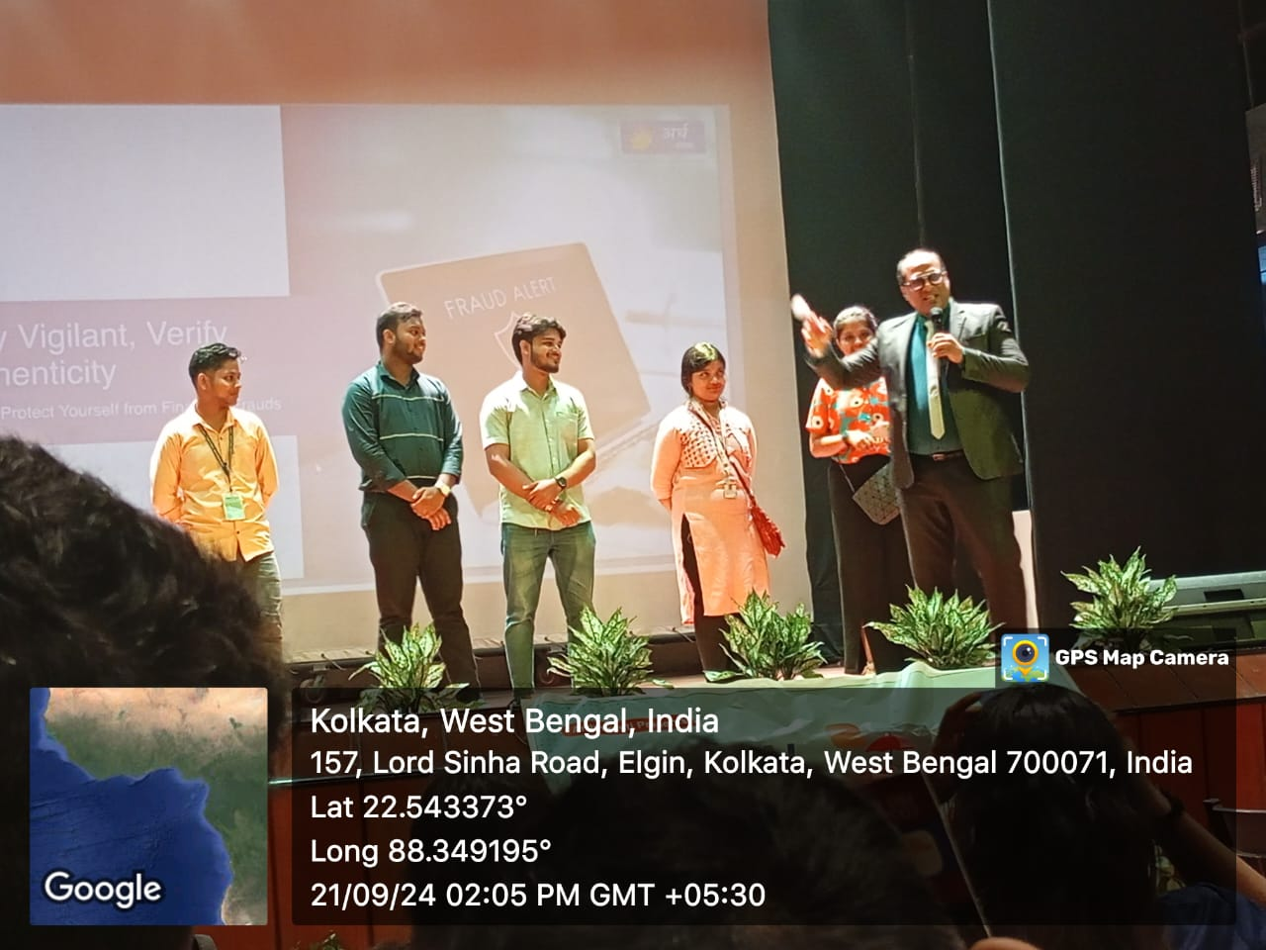

**Signature of Principal Signature of IQAC Coordinator**

**Signature of Excursion Guides**

**Subrata Das Doyel Aich Monalisa Bhowmick**